Title-1: Quantum-Safe Dynamic Data Auditing with Batch Verification for Blockchain-Enabled Edge-IoT Networks.

Title-2: Privacy-Preserving Multi-Authority Access Control in IoT: A Lattice-Based ZKProof Approach

Novelty: Zero Knowledge Proof + Batch Authentication
ZKP: Lyubashevsky’s "Fiat-Shamir with Aborts".
Batch Authentication: Probabilistic Small-Exponent Batching
For generating Challenge hash: SHAKE-256 (Keccak)
Workflow:
IoT Device registration through KGC

KGC calculates the secret keys (s) for particular device which is used to generate proofs

When an IoT device wants to send data (e.g., temperature readings), it does not send its ID or its secret key. Instead, it generates a Zero-Knowledge Proof (ZKP).

The device generates a random vector “y” and multiplies it with public matrix “A”
Commitment (w) = A*y. This locks “y” so that the device cannot change it later

Challenge generation: c=hash(w, message)

Response creation: z= y+(c*s). It contains the secret key mathematically "buried" inside it, but because of the random mask, the key cannot be extracted by anyone else.

Rejection sampling check: Device checks if looks "too similar" to the secret key.

If “z” reveals too much info, the device discards it and starts from commitment generation. If it looks safe (random), it proceeds.

The device sends the (message, c, z) to the server (blockchain node) without sending its ID.

The node doesn’t process the Tx immediately. It waits until it collects a batch of “N” no. of Tx received.

Random weight generation: Once the batch is full, the server generates a random numbers, one for each Tx.
**These random numbers are considered as "weights." They are critical security tools that prevent attackers from creating two fake transactions that cancel each other out to look valid.

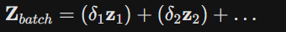
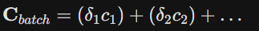
Batch Aggregation: sums up all the vectors:
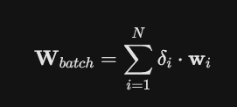

The server checks one single mathematical equation to validate all the “N” transaction.

The server checks if A*Z_batch - C_batch == W_batch, then the block is valid.

If the equation holds, the node packages all 100 transactions into a new Block and appends it to the Blockchain.

Else, the node knows at least one transaction is fake. It can then split the batch in half (Binary Search) to quickly find and discard the bad transaction.

Results to be calculated:
- Batch Verification Time
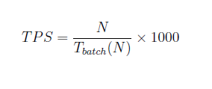
- Blockchain Throughput
- Computation cost (ms)
- Communication cost
- Storage overhead
- Scalability
- Efficiency

Reference papers:
- Blockchain-Enhanced Zero Knowledge Proof-Based Privacy-Preserving Mutual Authentication for IoT Networks
- Quantum Safe Lattice-Based Single Round Online Collaborative Multi-Signature Scheme for Blockchain-Enabled IoT Applications.

